How to setup a Jamulus Server on Amazon Lightsail

What is the server for?
This is the service that will allow you and your musician friends to participate in your own Jamulus session.

Where does the server run?
It runs on an Amazon machine, so you don’t’ have to be concerned with its maintenance. It can be running all the time so you or anyone from your group can setup a session at any time. I am suggesting the Amazon service simply because it is inexpensive and there is an excellent guide available on Facebook for you to follow.

How do I set it up?
This word document is based on a set of instructions already created - here is the link for the guide:
https://www.facebook.com/notes/jamulus-online-musicianssingers-jamming/howto-idiots-guide-to-installing-jamulus-server-on-amazon-aws-lightsail-ubuntu-i/507719749802976/
Note that each step must be followed exactly as is in the guide. The guide has screenshots at each stage to help you.
The next section in this document (not facebook) has isolated all the subsequent commands that you enter at the Setting up your Server section in the Facebook guide – shown in the screenshot here:
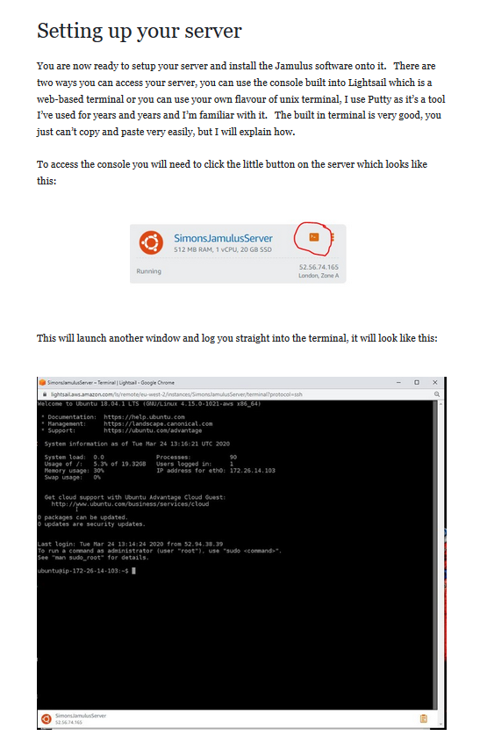
Up to this stage, instructions relate to setting up the Lightsail account and creating what is known as an Instance - think of it as a virtual computer that will run the Jamulus server software. Once that is done, you connect to the server (black terminal window) and enter a load of commands

All Commands

You could continue to follow the facebook guide step by step from this stage on or – follow the 3 steps shown here – which eliminates the explanations and screenshots. If you don’t need or want to know what these commands mean - then the simplest approach is to follow these 3 steps.
Step 1: Copy all the text in blue and paste into the black terminal window:
git clone https://github.com/corrados/jamulus.git llcon-jamulus
sudo apt update
sudo apt-get install build-essential qt5-qmake qtdeclarative5-dev libjack-jackd2-dev qt5-default

cd llcon-jamulus
qmake "CONFIG+=nosound" Jamulus.pro

At this stage you need to type in Y to confirm and press <ENTER>
Continue with copying and pasting these commands:

make clean
make
cd
sudo mv llcon-jamulus/ /usr/local/bin
sudo adduser --system --no-create-home jamulus
sudo mkdir /var/log/jamulus
sudo chown jamulus:nogroup /var/log/jamulus
sudo vi /etc/systemd/system/jamulus.service
Step 2: Edit the startup text in the vi text editor
At this stage you are in the vi text editor that is not very user friendly – your window should look like this:
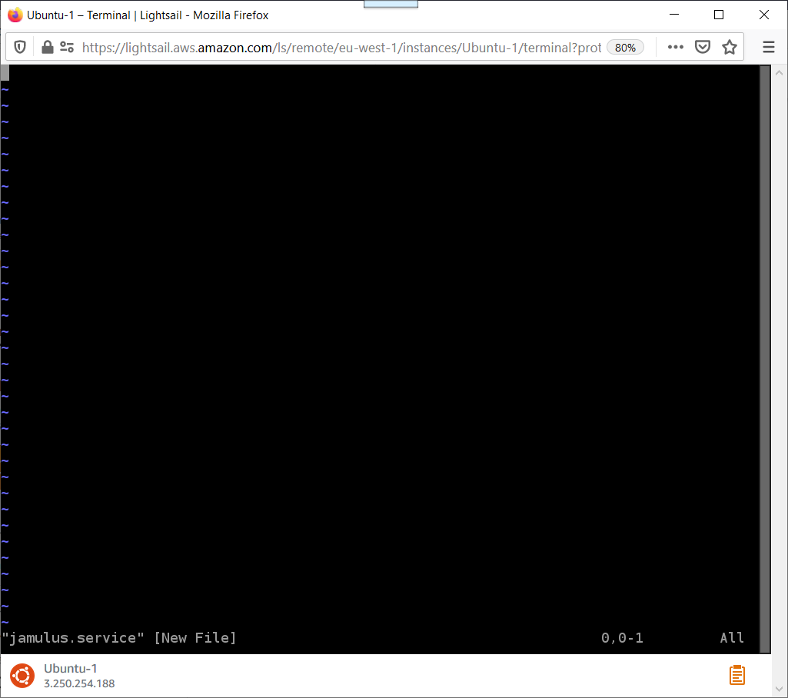
You will need to edit and then copy and paste the green text below.
Edit the text here in this word document that is red and give the server an appropriate name for your group. In this example – you should replace Octagon with your group’s name. If you are running the server from Ireland – do not change the text 104. You can also edit the welcome message. Once you have edited the text you can continue.

How do I control the maximum number of connections?
This is determined by the value assigned to the numchannels option – displayed in red text below. You can see that this example has a maximum of 10. This can be increased if you wish. I’m not sure what the maximum number of connections is.

How do I set my server to be private?
Your session will be private, in that only people with the IP address can connect, if you remove the line --centralserver jamulus.fischvolk.de \ from the text below. If you leave that line in – it will be listed in the connections window (there is a maximum number of servers that are listed so if you can’t see it there – that could be a reason).

Remember you are in the vi text editor – so type the letter i to start editing and then copy and paste all of the green text (including your edits) into the window.

[Unit]
Description=Jamulus-Central-Server
After=network.target
[Service]
Type=simple
User=jamulus
NoNewPrivileges=true
ProtectSystem=true
ProtectHome=true
Nice=-20
IOSchedulingClass=realtime
IOSchedulingPriority=0
# This line below is what you want to edit according to your preferences
ExecStart=/usr/local/bin/llcon-jamulus/Jamulus --server --nogui \
--log /var/log/jamulus/jamulus.log \
--centralserver jamulus.fischvolk.de \
--serverinfo "Octagon;Dublin;104" \
--welcomemessage "<h2>Welcome to the Octagon Server 2</h2>" \
--numchannels 10
# end of section you might want to alter
Restart=on-failure
RestartSec=30
StandardOutput=journal
StandardError=inherit
SyslogIdentifier=jamulus
[Install]
WantedBy=multi-user.target

Once pasted in it should look like this:
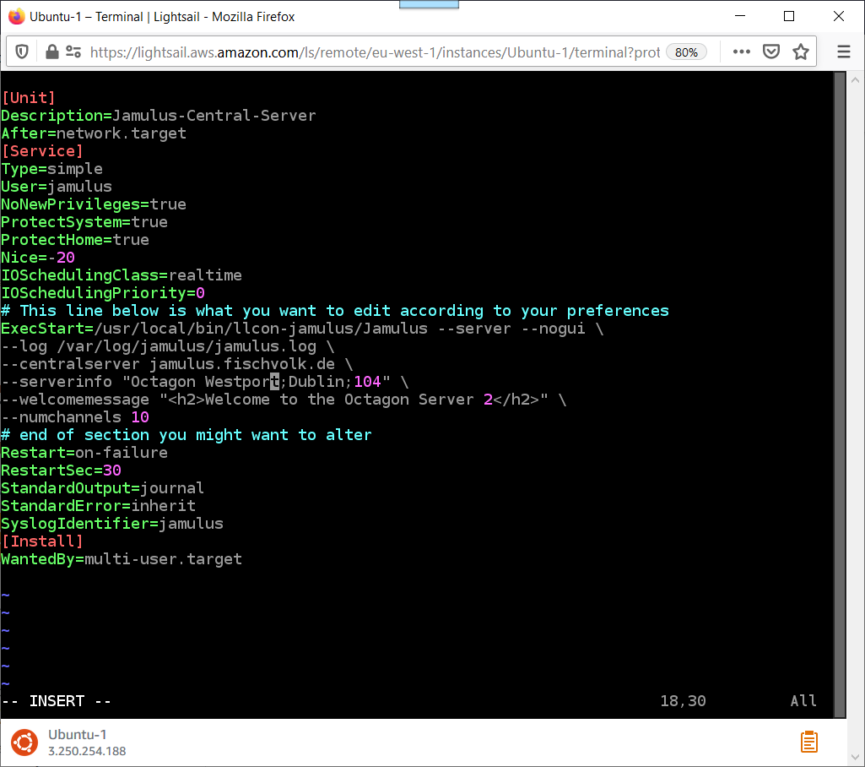

Hit the < ESC> key.
Type the following text :
:wq
Hit the <ENTER> key.
Step 3: Complete the setup by copying and pasting the commands in blue below:

cat /etc/systemd/system/jamulus.service
sudo chmod 644 /etc/systemd/system/jamulus.service
sudo systemctl start jamulus
cat /var/log/syslog
sudo systemctl enable jamulus

At this stage you have all the commands entered so you can close the black Terminal window.
You are now at this stage in the Facebook guide:
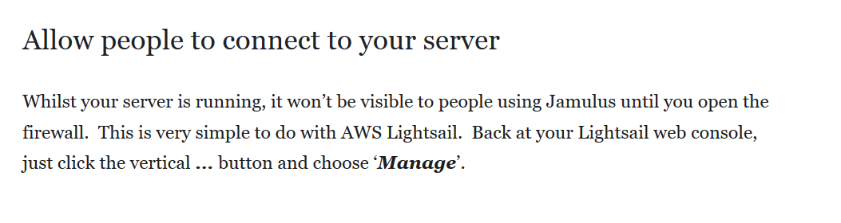
The Amazon Lightsail interface has changed slightly since this guide was written so instead of this:
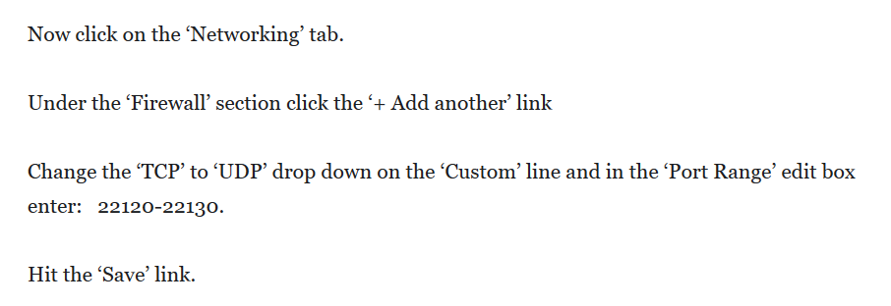

Follow this – the changes are in red.

Under the ‘Firewall’ section click the ‘+ Add rule’ link
Change the ‘TCP’ to ‘UDP’ drop down on the ‘Custom’ line and in the ‘Port Range’ edit box enter: 22120-22130.

Hit the ‘Create’ link.

Create a static IP address
The Facebook guide does not go through this task. It’s simple enough;
Users will connect to your Jamulus server using the public IP address - you can find out what the IP address is from the Home screen of your Lightsail account:
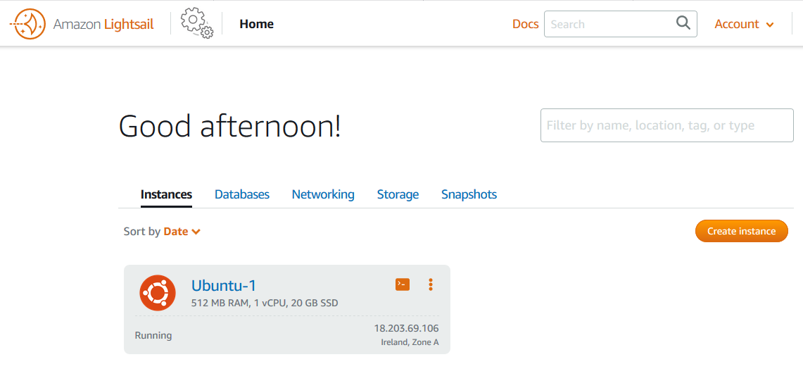

Here you will see that my instance is called the default name Ubuntu-1, and the public IP address is 18.203.69.106. This IP address is what users use to connect to Jamulus, but this is a dynamic IP address and can change randomly so you need to create a static address that will not change. Here are the instructions:
Click on Networking (from the Home page) and click on Create static IP:
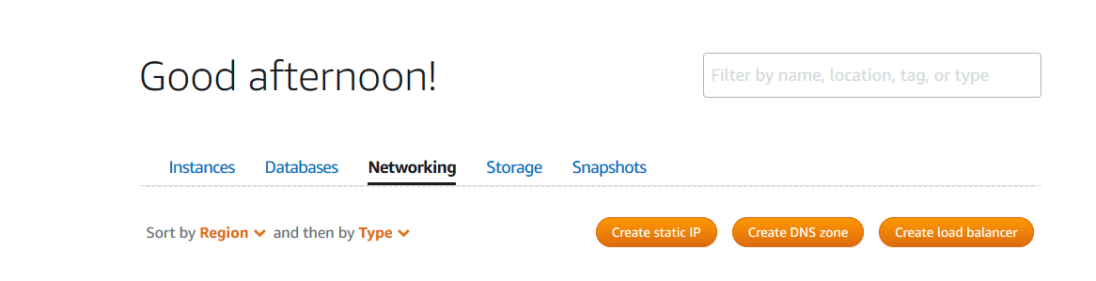

Next click on the down arrow to select your Jamulus instance (mine is Ubuntu-1);

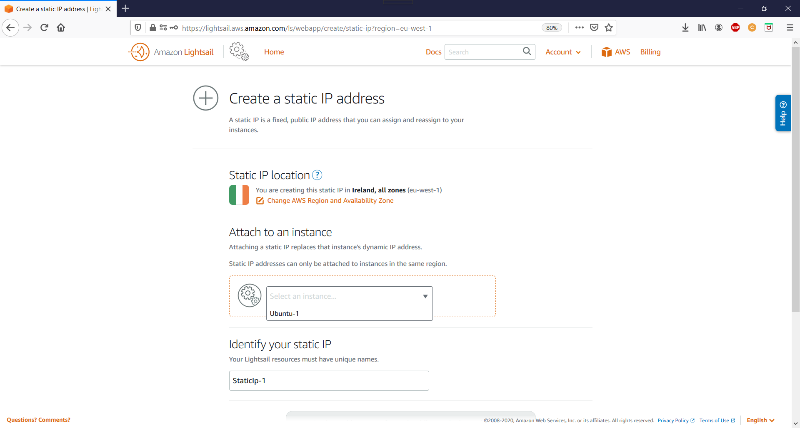
Next give your Static IP a name e.g. JamulusIP – the default is StaticIp-1
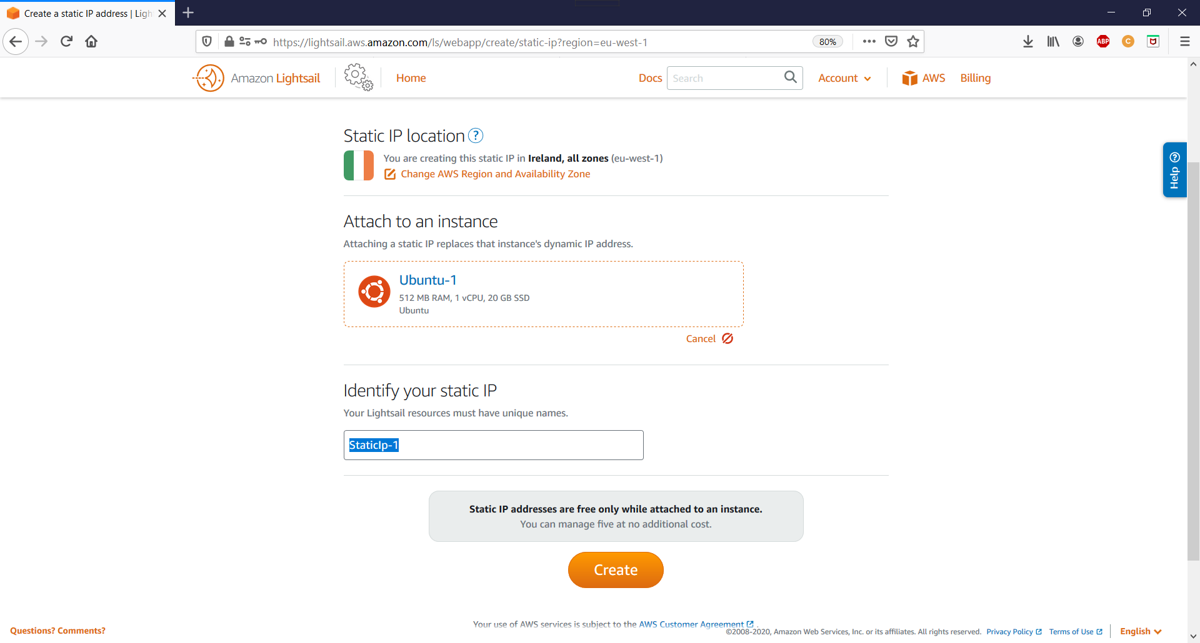
Click Create. Note the warning message: Static IP addresses are free only while attached to an instance. Once you have clicked Create – it will be created and attached to your Jamulus server and accessible for all users. But if you detach it (you shouldn’t need to), delete the static IP or you will be charged for it.
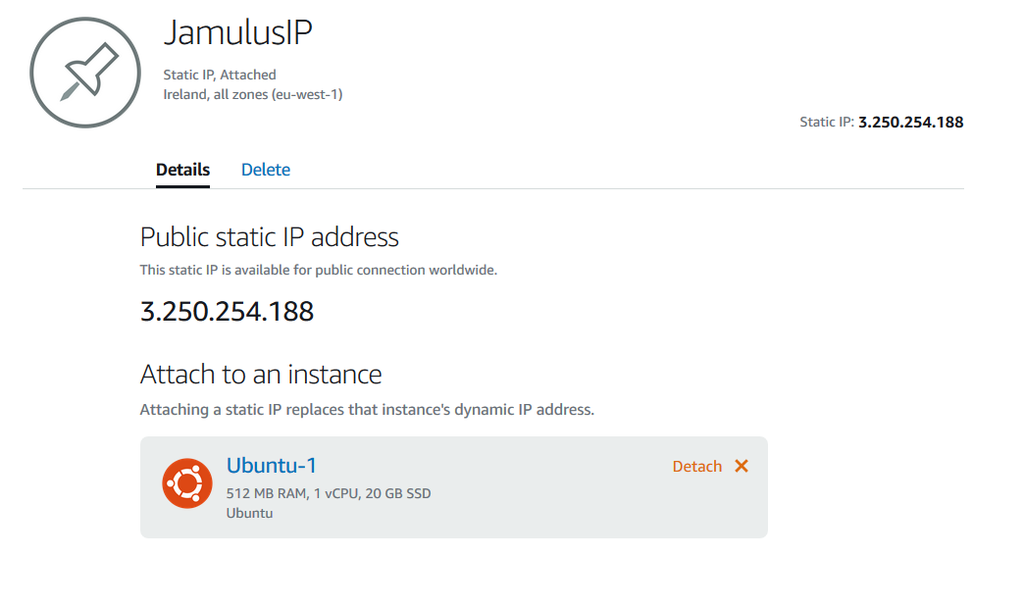

The IP address is what you and your fellow musicians use to connect to the server when you run the Jamulus program on your PC.
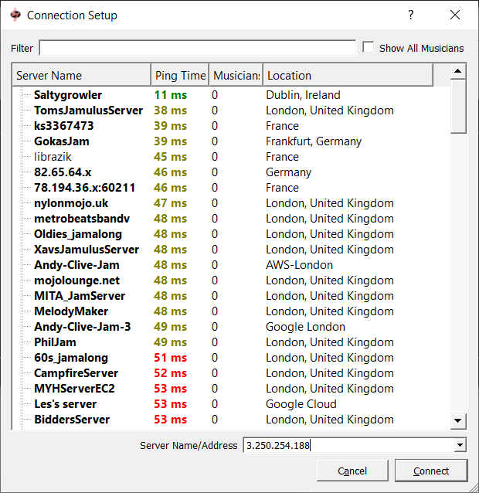

You are ready to go! Happy Jamming.

Allow Ping to test speed
You can test the communication speed between your computer and your server using the Ping command.
First, you need to tell your server to allow ping requests - follow instructions here to create a new firewall rule for ping service:
https://aws.amazon.com/blogs/compute/enhancing-site-security-with-new-lightsail-firewall-features/

Ping on Windows
If you are not sure – this link will show you how https://www.betterhostreview.com/how-to-ping-windows-10.html
On windows run ping from a command line
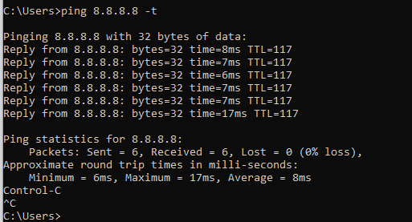

Remember to substitute your server’s public IP address for what is shown above.

Ping on Mac
If you are not sure – this link will show you how https://www.macworld.co.uk/how-to/mac/ping-test-mac-3524076/.

